The University of Azad Jammu and Kashmir, Muzaffarabad



Name | Muhammad Hasham Munir Qazi
Roll no | 2024-SE-32
Semester | ^{4th}
Batch | 2024-2028
Subject | Database Systems
Lab | 01
Submitted to | Engr. M. Awais Rathore
Submission date | June 01, 2026

Department of Software Engineering

Lab Task: Installation of Xampp ( Apache, MariaDB, Php and Pearl) – A software that makes computer local server and enables it to run PHP

- First of all, we need to download zip file from the official website of Xampp. In my case, Macintosh, I have downloaded .dmg file.

- Having it downloaded and installed, the next step is to open it and start the server namely Apache and SQL

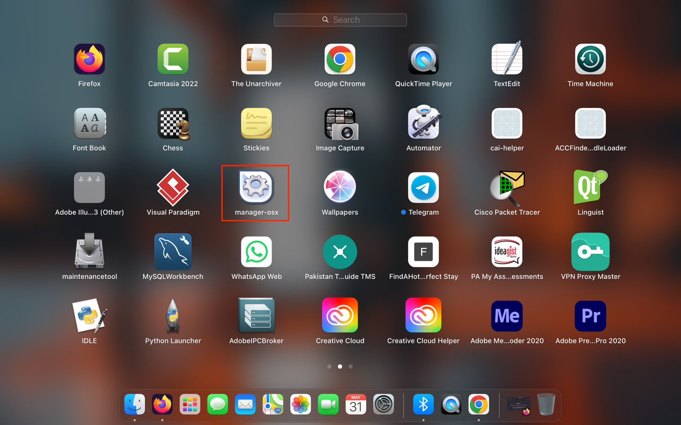
The screenshots for these tasks are in the following:

